**Midterm Lab Task 4  
Using Dictionary Collections**

Problem 1. Create the following UI for menu items: then allow the user to input orders

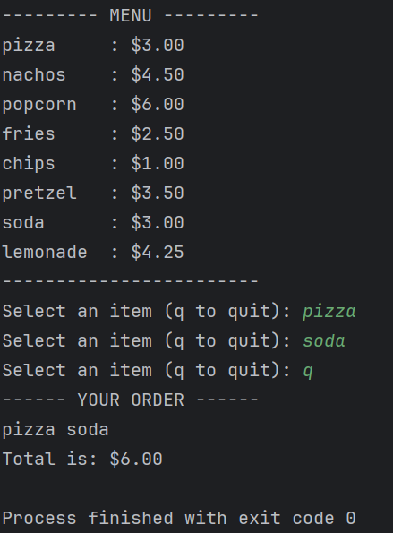

The user will continue to input orders until q is typed to quit. Then display the summary of orders with the total bill.

1. Use a dictionary(for the menu) and List(for the orders in the cart)
2. Users may input the same item in the cart.
3. Follw the exact format and whitespace for the menu
4. User input should be case insensitive
5. If the user inputted an item not in the Menu – it will not include it in the cart and display “Not Available” and input another item
6. Create a MENU with 10 items and assign prices in Peso (php) - You may choose what items you would like to put in your cart